BANK LOAN REPORT QUERY DOCUMENT
- BANK LOAN REPORT | SUMMARY
KPI’s:
Total Loan Applications
SELECTCOUNT(id)ASTotal_ApplicationsFROMbank_loan_data
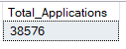
MTD Loan Applications
SELECTCOUNT(id)ASTotal_ApplicationsFROMbank_loan_data
WHEREMONTH(issue_date)= 12
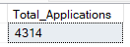
PMTD Loan Applications
SELECTCOUNT(id)ASTotal_ApplicationsFROMbank_loan_data
WHEREMONTH(issue_date)= 11
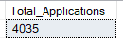

Total Funded Amount
SELECTSUM(loan_amount)ASTotal_Funded_AmountFROMbank_loan_data
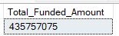
MTD Total Funded Amount
SELECTSUM(loan_amount)ASTotal_Funded_AmountFROMbank_loan_data
WHEREMONTH(issue_date)= 12
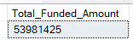
PMTD Total Funded Amount
SELECTSUM(loan_amount)ASTotal_Funded_AmountFROMbank_loan_data
WHEREMONTH(issue_date)= 11
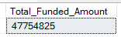

Total Amount Received
SELECTSUM(total_payment)ASTotal_Amount_CollectedFROMbank_loan_data
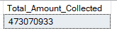
MTD Total Amount Received
SELECTSUM(total_payment)ASTotal_Amount_CollectedFROMbank_loan_data
WHEREMONTH(issue_date)= 12
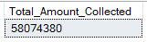
PMTD Total Amount Received
SELECTSUM(total_payment)ASTotal_Amount_CollectedFROMbank_loan_data
WHEREMONTH(issue_date)= 11
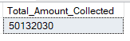

Average Interest Rate
SELECTAVG(int_rate)*100 ASAvg_Int_RateFROMbank_loan_data
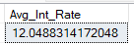
MTD Average Interest
SELECTAVG(int_rate)*100 ASMTD_Avg_Int_RateFROMbank_loan_data
WHEREMONTH(issue_date)= 12
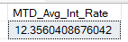
PMTD Average Interest
SELECTAVG(int_rate)*100 ASPMTD_Avg_Int_RateFROMbank_loan_data
WHEREMONTH(issue_date)= 11
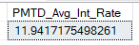

Avg DTI
SELECTAVG(dti)*100 ASAvg_DTIFROMbank_loan_data
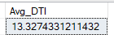
MTD Avg DTI
SELECTAVG(dti)*100 ASMTD_Avg_DTIFROMbank_loan_data
WHEREMONTH(issue_date)= 12
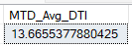
PMTD Avg DTI
SELECTAVG(dti)*100 ASPMTD_Avg_DTIFROMbank_loan_data
WHEREMONTH(issue_date)= 11
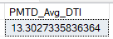

GOOD LOAN ISSUED
Good Loan Percentage
SELECT
(COUNT(CASEWHENloan_status='Fully Paid'ORloan_status='Current'THEN id END)* 100.0)/
COUNT(id)ASGood_Loan_Percentage
FROMbank_loan_data
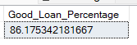
Good Loan Applications
SELECTCOUNT(id)ASGood_Loan_ApplicationsFROMbank_loan_data
WHEREloan_status='Fully Paid'ORloan_status='Current'
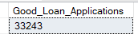
Good Loan Funded Amount
SELECTSUM(loan_amount)ASGood_Loan_Funded_amountFROMbank_loan_data
WHEREloan_status='Fully Paid'ORloan_status='Current'
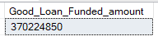

Good Loan Amount Received
SELECTSUM(total_payment)ASGood_Loan_amount_receivedFROMbank_loan_data
WHEREloan_status='Fully Paid'ORloan_status='Current'
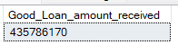

BAD LOAN ISSUED
Bad Loan Percentage
SELECT
(COUNT(CASEWHENloan_status='Charged Off'THEN id END)* 100.0)/
COUNT(id)ASBad_Loan_Percentage
FROMbank_loan_data
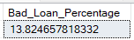
Bad Loan Applications
SELECTCOUNT(id)ASBad_Loan_ApplicationsFROMbank_loan_data
WHEREloan_status='Charged Off'
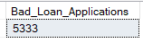
Bad Loan Funded Amount
SELECTSUM(loan_amount)ASBad_Loan_Funded_amountFROMbank_loan_data
WHEREloan_status='Charged Off'
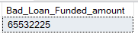
Bad Loan Amount Received
SELECTSUM(total_payment)ASBad_Loan_amount_receivedFROMbank_loan_data
WHEREloan_status='Charged Off'
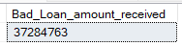

LOAN STATUS
SELECT
loan_status,
COUNT(id)ASLoanCount,
SUM(total_payment)ASTotal_Amount_Received,
SUM(loan_amount)ASTotal_Funded_Amount,
AVG(int_rate* 100)ASInterest_Rate,
AVG(dti* 100)AS DTI
FROM
bank_loan_data
GROUPBY
loan_status
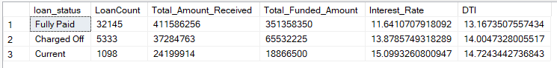

SELECT
loan_status,
SUM(total_payment)ASMTD_Total_Amount_Received,
SUM(loan_amount)ASMTD_Total_Funded_Amount
FROMbank_loan_data
WHEREMONTH(issue_date)= 12
GROUPBYloan_status
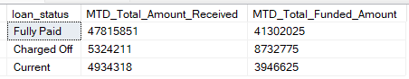

- BANK LOAN REPORT | OVERVIEW
MONTH
SELECT
MONTH(issue_date)ASMonth_Munber,
DATENAME(MONTH,issue_date)ASMonth_name,
COUNT(id)ASTotal_Loan_Applications,
SUM(loan_amount)ASTotal_Funded_Amount,
SUM(total_payment)ASTotal_Amount_Received
FROMbank_loan_data
GROUPBYMONTH(issue_date),DATENAME(MONTH,issue_date)
ORDERBYMONTH(issue_date)
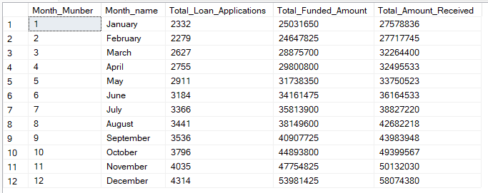

STATE
SELECT
address_stateASState,
COUNT(id)ASTotal_Loan_Applications,
SUM(loan_amount)ASTotal_Funded_Amount,
SUM(total_payment)ASTotal_Amount_Received
FROMbank_loan_data
GROUPBYaddress_state
ORDERBYaddress_state
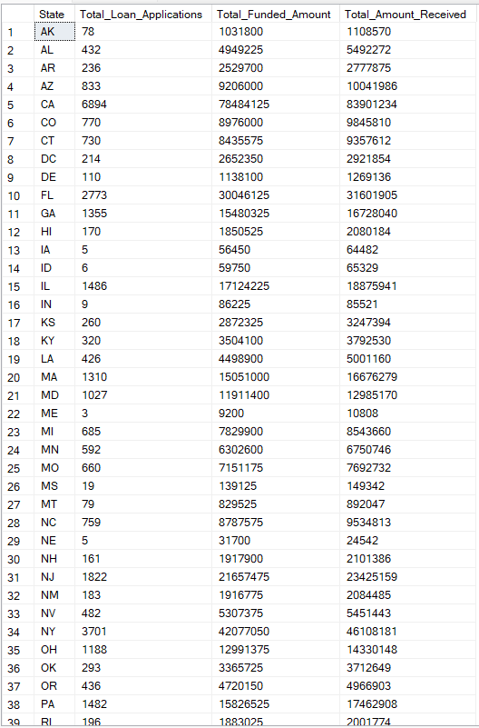

TERM
SELECT
term AS Term,
COUNT(id)ASTotal_Loan_Applications,
SUM(loan_amount)ASTotal_Funded_Amount,
SUM(total_payment)ASTotal_Amount_Received
FROMbank_loan_data
GROUPBY term
ORDERBY term
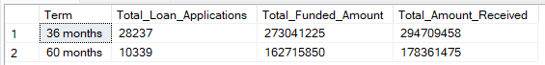

EMPLOYEE LENGTH
SELECT
emp_lengthAS Employee_Length,
COUNT(id)ASTotal_Loan_Applications,
SUM(loan_amount)ASTotal_Funded_Amount,
SUM(total_payment)ASTotal_Amount_Received
FROMbank_loan_data
GROUPBYemp_length
ORDERBYemp_length
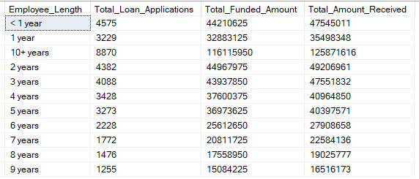
PURPOSE
SELECT
purpose AS PURPOSE,
COUNT(id)ASTotal_Loan_Applications,
SUM(loan_amount)ASTotal_Funded_Amount,
SUM(total_payment)ASTotal_Amount_Received
FROMbank_loan_data
GROUPBY purpose
ORDERBY purpose
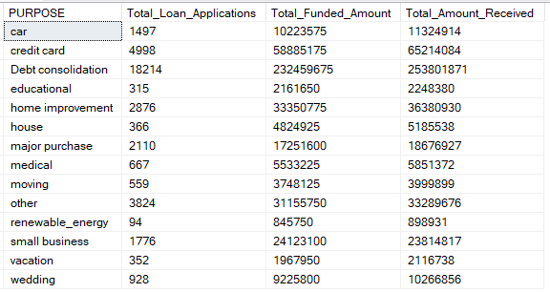

HOME OWNERSHIP
SELECT
home_ownershipASHome_Ownership,
COUNT(id)ASTotal_Loan_Applications,
SUM(loan_amount)ASTotal_Funded_Amount,
SUM(total_payment)ASTotal_Amount_Received
FROMbank_loan_data
GROUPBYhome_ownership
ORDERBYhome_ownership
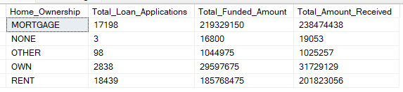

Note: We have applied multiple Filters on all the dashboards. You can check the results for the filters as well by modifying the query and comparing the results.
For e.g
See the results when we hit the Grade A in the filters for dashboards.
SELECT
purpose AS PURPOSE,
COUNT(id)ASTotal_Loan_Applications,
SUM(loan_amount)ASTotal_Funded_Amount,
SUM(total_payment)ASTotal_Amount_Received
FROMbank_loan_data
WHERE grade ='A'
GROUPBY purpose
ORDERBY purpose

